Lab04 : Python Loops
Name | Nneoma Onwe
Date | Onwe

Exercise 1: Defining and Calling a Void Function
Exercise 1 – void functions
Modify the example code above to generate the following output.
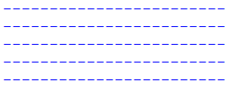
Hint: use a for loop to call the printLine() function the required number of times. Save the modified file as lab4ex1.py

Copy your Python code here. Make sure that your code contains your name and date.
#functions definitions
def printLine():
print("--------------")
#function call
for _ in range(4):
printLine()

Paste screen capture here showing the program being run

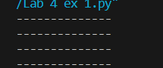

Answer the following questions in it:

- What is the purpose of a function?
A function's purpose is to encapsulate a sequence of instructions or operations into a reusable block of code. Functions allow for modular programming, which improves code organization, readability, and maintainability. They can be called repeatedly with different parameters, allowing for code reuse and reducing redundancy. Functions also help to break down complex problems into smaller, more manageable tasks, making code easier to understand and debug.

Exercise 2: Returning Value from a Function
Create a file as lab4ex2.py that is that asks the user to enter a well known TCP port number in the range 1 to 1023 and then displays the port number.

def getPort():

port = int(input("Enter a well-known TCP port number (1-1023): "))
if 1 <= port <= 1023:

return port
else:
return 0

port_number = getPort()
print("The entered port number is:", port_number)

Paste screen capture here showing the program being run

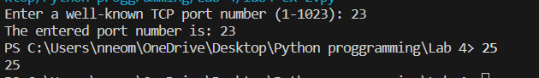

Answer the following questions in it:

- How does Python return a value from a function?
A function can return a value by using the return statement. When a return statement is encountered within a function, the function terminates and returns the specified value to the caller. This returned value can then be set as a variable or used in an expression.

Exercise 3 – Passing values to Function
Create a program as lab4ex3.py that calls a function computeAverage(x, y, z) that when passed three numbers will return the average of these three numbers. The program should display the result on the command line.
[Hint – you computed the average of three numbers in lab1 (lab1ex2.py)
Copy your Python code here. Make sure that your code contains your name and date.

def avg (x,y,z):
return x+y+z /3

result= avg(10,12,13)
print("average is ",result)

Paste screen capture here showing the program being run

Explain the meaning of the term “argument” and “parameter” in the context of Python functions:
Parameters are the variables declared in a function's definition, whereas arguments are the values or variables passed to the function when it is invoked. Parameters define the function's interface, whereas arguments are the data that passes through that interface when the function is called.

Additional Practice Exercises
Log your work on the additional practice exercises here.
Exercise 4
def getPort():
port = int(input("Enter a well-known TCP port number (1-1023): "))
if 1 <= port <= 1023:
return port
else:
return 0

port_number = getPort()
print("The entered port number is:", port_number)

def isValidPort(port):
if 1 <= port <= 1023:
return True
else:
return False

def displayPort():
port = getPort()
if isValidPort(port):
print("The entered port number is:", port)
else:
print("Invalid port number. Please try again.")

displayPort()

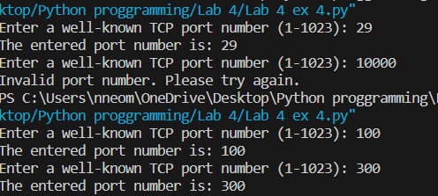

Ex 5

#Lab 4 ex 5.py
def getLength():
length = int(input("Enter the length of the rectangle: "))
return length

def getWidth():
width = int(input("Enter the width of the rectangle: "))
return width

def calculateArea(length, width):
area = length * width
return area

def displayArea():
length = getLength()
width = getWidth()
area = calculateArea(length, width)
for i in range(length):
if i == 0 or i == length - 1:
print('*' * width)
print("The area of the rectangle is:", area)

def main():
displayArea()

main()

